CHAPTER 5: Separating mixtures
Worksheet 5.8

Separation techniques
Science Quest 7: pages 199–201
Student: Class:
1. Complete the table to summarise what you know about separation techniques.
Method of separation | Description of how it works | An example of how it is used in the home or in industry
Filtration
Distillation
Crystallisation
Flocculation
Decanting
Separating funnel
Centrifuging
Chromatography

2. The diagram on the right shows a mixture being filtered in a school laboratory.
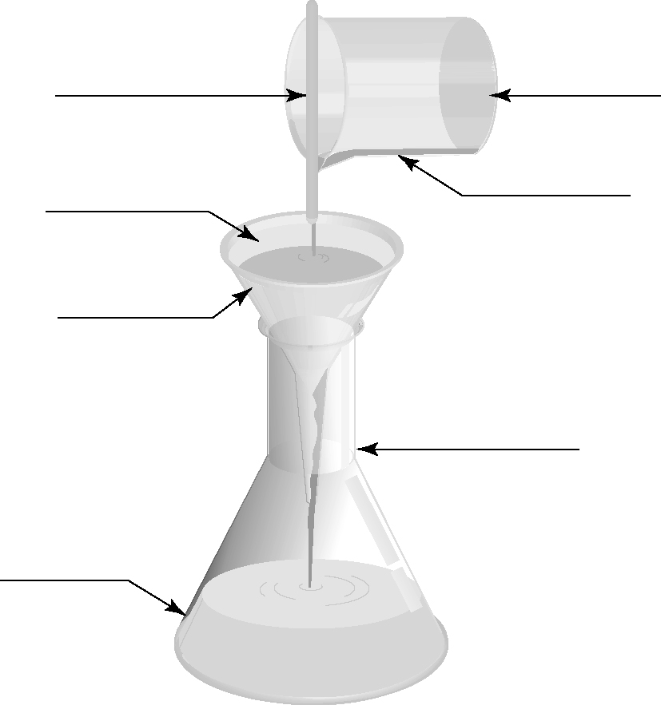
(a) Add the missing labels.
(b) What is the purpose of the stirring rod?
……………………………………………………
……………………………………………………
……………………………………………………
……………………………………………………
CHAPTER 5: Separating mixtures PAGE 2
Worksheet 5.8

3. Complete the following word puzzle, using the clues provided below.

(a) S ___ ___ ___ ___ ___
(b) ___ E ___ ___ ___ ___
(c) ___ ___ ___ D ___ ___ ___ ___ ___ ___ ___ ___
(d) ___ ___ ___ ___ ___ I ___ ___ ___ ___
(e) ___ ___ ___ ___ M ___ ___ ___ ___ ___ ___ ___ ___ ___
(f) ___ ___ ___ ___ ___ ___ E
(g) ___ N ___ ___ ___ ___ ___ ___ ___
(h) ___ ___ ___ T ___ ___ ___ ___ ___ ___
(i) ___ ___ ___ ___ ___ ___ ___ A ___ ___ ___ ___
(j) ___ ___ ___ ___ ___ ___ ___ T ___ ___ ___
(k) ___ ___ ___ ___ ___ ___ I ___ ___
(l) ___ O ___ ___ ___ ___ ___
(m) ___ ___ ___ ___ ___ N ___ ___ ___ ___

Clues

(a) A substance that dissolves in a liquid
(b) Refers to our body’s waste products
(c) When steam changes to liquid water
(d) An instrument used to separate plasma from blood cells
(e) A method of separating mixtures of dyes or inks
(f) The material trapped by the filter paper
(g) When a substance does not dissolve in a liquid we say it is ................................ .
(h) A method of separation used to clean the air going into a car engine
(i) A method of separation used to purify water
(j) A process used to obtain salt from sea water
(k) A process used to separate mineral ores from gangue
(l) A liquid in which a substance will dissolve
(m) Undissolved particles spread throughout a liquid

